Task 4 Report
IoT Cloud Integration and Real-Time Temperature Monitoring System using ESP32 and ThingSpeak

Objective
To develop an IoT-based Smart Temperature Control System using an ESP32, Analog Temperature Sensor (NTC), and ThingSpeak cloud platform. The system measures temperature, controls an LED automatically based on a threshold, and uploads temperature readings to ThingSpeak for real-time visualization.

Components Used
• ESP32 Dev Board
• Analog Temperature Sensor (NTC)
• LED
• 220 Ω Resistor
• ThingSpeak Cloud
• Wokwi Simulator
• Wi-Fi

Circuit Connections
Component | Connection
NTC VCC | 3.3V
NTC GND | GND
NTC AO | GPIO36 (VP)
LED Anode | GPIO21 through 220 Ω resistor
LED Cathode | GND

Working
The ESP32 continuously reads the analog value from the NTC temperature sensor and converts it into temperature. The measured value is compared with a predefined threshold. When the temperature exceeds the threshold, the ESP32 turns the LED ON; otherwise, it turns the LED OFF. Every 20 seconds, the ESP32 sends the temperature reading to the ThingSpeak cloud through Wi-Fi. ThingSpeak stores the data and displays it as a real-time graph for remote monitoring.

Circuit diagrams
Figure 1: Circuit Diagram and Code
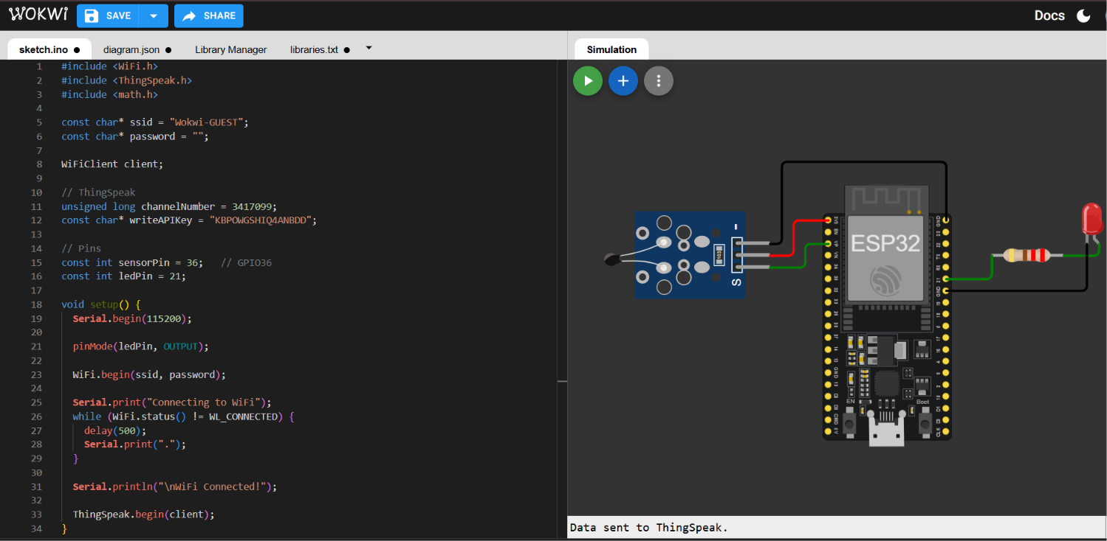
Figure 2: Simulation Output (LED ON and Serial Monitor)
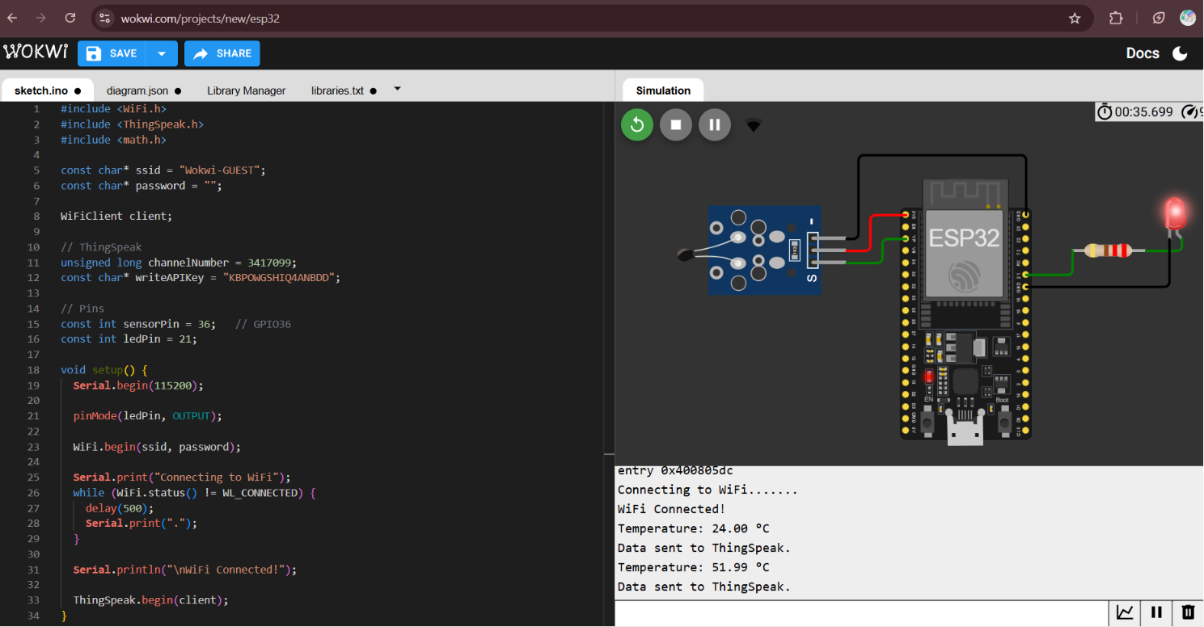
Figure 3: Temperature Adjustment
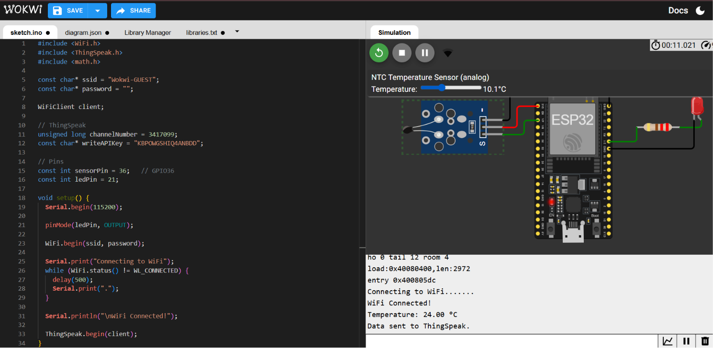
Figure 4: ThingSpeak Cloud Graph
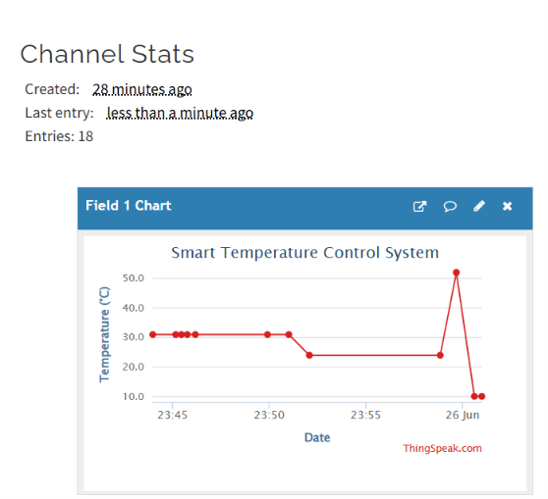

Results
• ESP32 successfully connected to Wi-Fi.
• Temperature sensor measured the surrounding temperature.
• LED automatically turned ON/OFF based on the temperature threshold.
• Temperature readings were successfully uploaded to ThingSpeak.
• ThingSpeak displayed the live temperature graph.

Conclusion
The project successfully demonstrates an IoT-based smart temperature monitoring and control system using ESP32 and ThingSpeak. Real-time temperature values were monitored, the LED responded automatically to temperature changes, and the cloud dashboard confirmed successful data transmission.

